actical File
Project File
(Physics)
2022-23



Name: Deepak Soni
Class : 12th (Science)
School: Kaliram Chandrakar
Public School, Kurud
Roll No. : 12143

CERTIFICATE
This is to certify that the contents of this project file submitted by Deepak Soni of class XII for the subject of Computer Science is his bonafide work submitted to Kaliram Chandrakar Public School, Kurud for partial fulfilment of the requirements for CBSE examinations of class XII.
The project has been completed under my guidance and supervision. Deepak Soni has been working on the completion of the project sincerely from start to finish. I certify that the project is up to my expectations and can be submitted for evaluation.

Sign. Of Principal

Sign. of Subject Teacher Sign. External Examiner
ACKNOWLEDGEMENT
I would like to express my special thanks of gratitude to my English teacher Mr. Gaurav Gupta Sir as well as our principal Mr. Devlal Yadav who gave me the golden opportunity to do this wonderful project on the topic Semiconductors.

Secondly, I would also like to thank my parents and friends who helped me a lot in finalizing this project within the limited time frame.

Lastly, I like to thank all my supporters who have motivated me to fulfill their project before the timeline.

Date:08/01/2023 “Deepak Soni”
12th (science)

Basic Electronics

Zener Diode

Introduction:-

A normal P-N junction diode is usually fabricated by adjusting the P-type and N-type semiconductors on a single semiconductor crystal. The characteristics of a junction diode demonstrate that it is designed largely for operating in the forward direction. Applying a large amount of forward bias causes greater forward current with a small value of forward voltage.

However, reverse biasing the diode do not cause conduction of current till high values of reverse voltage are reached. If the reverse voltage is large enough, breakdown occurs and a reverse current starts to flow. Ordinary Junction diodes are generally damaged when this breakdown occurs. The flow of current in zener diodes is controlled by the minority charge carriers under the reverse bias condition, so they can also be referred to as break down diodes.

During specific conditions of fabrication, a special type of diode is formed that will not be ruined when the breakdown voltage is increased, given that the current does not exceed a defined limit to prevent the case of overheating. This type of devices is referred to as zener diodes.

Zener diodes allow current to flow in the forward direction in the similar manner as an ideal diode, and also it permits current to flow in the reverse direction when the voltage is above a certain value known as the breakdown voltage. This voltage can also be referred as zener knee voltage or zener voltage.
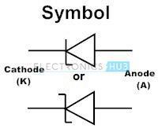
Zener Diode I-V Characteristics Curve

In the forward bias condition, the zener diode behaves like an ideal diode within specified current and power limits, but it differs in reverse bias condition where the zener diode has very steep avalanche characteristic at the breakdown voltage in reverse bias condition.

Zener operates mainly in the reverse bias mode by connecting anode to the negative terminal of the power supply. Zener diodes are categorised and rated by the voltage at which they will turn on or start to conduct the reverse bias current.
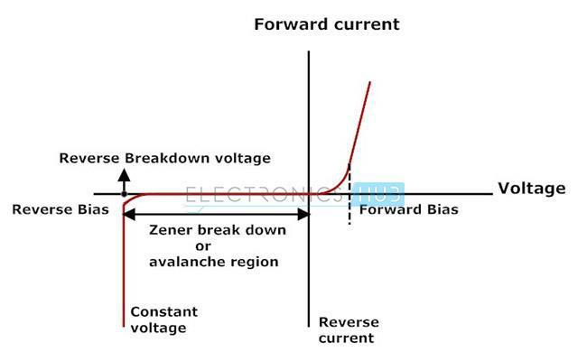

Generally these zener diodes are used to regulate the voltage. In reverse bias condition after the break down zener diode provides a constant output voltage even if we increase the input voltage. There are specifically two separate mechanisms that might cause a breakdown in a zener diode:

Avalanche Breakdown

It is predominant above approximately 5.5 volts. This mechanism is also referred to as impact ionisation or avalanche multiplication. For reverse conduction it is necessary to visualise the phenomenon of avalanche breakdown. This process begins when a large negative bias is applied to the PN junction, sufficient energy is imparted to thermally generated minority charge carriers in the semiconductors.

As a result the free carriers acquire required kinetic energy to break the covalent bonds and create an electric field through collisions with crystal particles. The charge carriers created in collision contribute to the reverse current, well beyond the normal reverse saturation current and may also possess enough energy to participate through collisions, creating an additional electric field and the

avalanche effect by impact ionization, once a sufficiently high reverse bias is provided this process of conduction takes place very much like an avalanche: a single electron can ionise several others.

Zener Breakdown

It is predominant below approximately 5.5 volts. This mechanism is also referred to as a high field emission mechanism. The phenomenon of zener breakdown is related to the concept of avalanche breakdown. Zener breakdown is achieved by heavily doped regions in the neighbourhood of ohmic contact.

It is the second method of disturbing the covalent bonds of the crystal atoms and increasing the reverse bias zener diode current, to be sustained at a much lower specific voltage than normal diode. The reverse bias voltage known as zener voltage, where this mechanism occurs is determined by the diode doping concentration and it occurs when the depletion layer field width is sufficiently enough to disrupting the covalent bonds and cause number of free charge carriers due to electric field generation to swell.

Zener Diode as Voltage Regulator

I-V characteristics of zener diode make it suitable for application such as a voltage regulator. A voltage stabilizer is a combination of elements that are designed to ensure the output voltage of a supply fairly remains constant. Excess voltage protection is done by using zener diodes because there will be reverse current due to minority charge carriers starts flowing through the diode after the reverse bias voltage exceeds a certain value.

Keeping the zener diode in parallel with a variable load resistance R_{L}, ensures a constant output voltage even though the load current and the supply voltage varies. In practical circuits the simplest form of current source is a resistor. The key in using the zener diode as voltage regulator is that as long as the zener diode is reverse biased, the flow of current greater than a few micro amperes must be accompanied by a voltage greater than the Zener voltage.

This type of arrangement of the circuit provides safety for equipment connected to terminals. This arrangement of regulator circuit is referred to as a shunt regulator in which the regulating element is placed in parallel with the load. The input voltage to the system is a few volts and as long as it is more than the desired output voltage, a stable voltage will be produced across the zener diode.

As the input voltage increases, current through the zener diode increases, but the drop in voltage remains constant which is the necessary feature required for zener diodes. Therefore, reverse current in the circuit has increased, voltage drop across the resistor increases by an amount equal to the difference between the applied input voltage and the zener knee voltage of the zener diode.

The output voltage of regulator system is fixed as the zener knee voltage of the zener diode and can be used in power devices requiring a fixed voltage of firm value. The zener diode will continue in regulating the voltage till the zener diode current falls below the minimum I_{z min} value in the reverse breakdown region.

The source resistance R_{s} is connected in series with zener diode to limit the flow of current through the diode with voltage source connected across the combination. The cathode terminal of zener diode is connected to the positive terminal of the voltage source so that the zener diode is biased in reverse condition and will be operating in breakdown region.
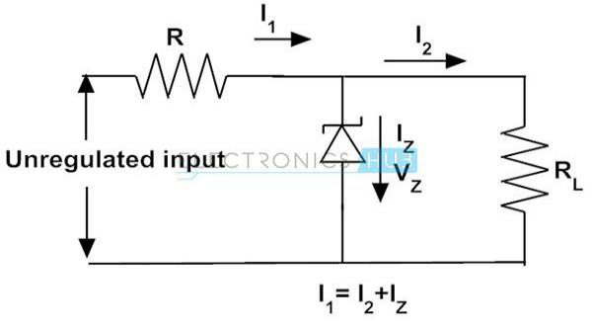

When the load is not connected across the zener diode, no load current will be conducted and all the current due to the circuit will pass through the zener diode dissipating maximum amount of power that causes overheating of the diode and damages permanently.

Selecting the appropriate values of series resistance R_{s} is also important because it also causes greater diode current, so that maximum power dissipation of the diode should not be exceeded under no load or at high impedance condition.

Whenever a load is connected in parallel with zener diode, voltage across the load is same as the zener diode voltage. However the source voltage must be greater than the zener voltage and the upper limit of zener current depends on the power rating of the zener diode; otherwise the zener voltage will simply follow the applied input voltage.
Bipolar Junction Transistor

The Bipolar Transistor basic construction consists of two PN-junctions producing three connecting terminals with each terminal being given a name to identify it from the other two. These three terminals are known and labelled as the Emitter ( E ), the Base ( B ) and the Collector ( C ) respectively.

Bipolar Transistors are current regulating devices that control the amount of current flowing through them from the Emitter to the Collector terminals in proportion to the amount of biasing voltage applied to their base terminal, thus acting like a current-controlled switch. As a small current flowing into the base terminal controls a much larger collector current forming the basis of transistor action.

The principle of operation of the two transistor types PNP and NPN, is exactly the same the only difference being in their biasing and the polarity of the power supply for each type.

Bipolar Transistor Construction:-
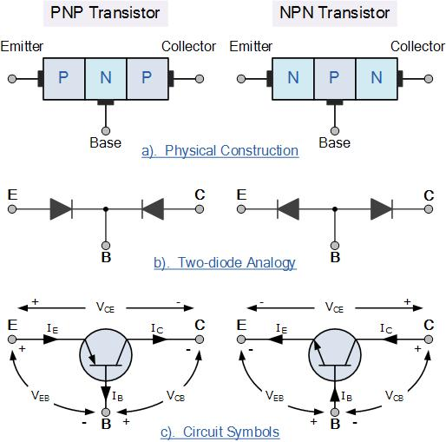

The construction and circuit symbols for both the PNP and NPN bipolar transistor are given above with the arrow in the circuit symbol always showing the direction of “conventional current flow” between the base terminal and its emitter terminal. The direction of the arrow always points from the positive P-

type region to the negative N-type region for both transistor types, exactly the same as for the standard diode symbol.

Bipolar Transistor Configurations

As the Bipolar Transistor is a three terminal device, there are basically three possible ways to connect it within an electronic circuit with one terminal being common to both the input and output. Each method of connection responding differently to its input signal within a circuit as the static characteristics of the transistor vary with each circuit arrangement.

• Common Base Configuration

– has Voltage Gain but no Current Gain.

• Common Emitter Configuration

– has both Current and Voltage Gain.

- Common Collector Configuration – has Current Gain but no Voltage Gain.

The Common Base (CB) Configuration

As its name suggests, in the Common Base or grounded base configuration, the BASE connection is common to both the input signal AND the output signal. The input signal is applied between the transistors base and the emitter terminals, while the corresponding output signal is taken from between the base and the collector terminals as shown. The base terminal is grounded or can be connected to some fixed reference voltage point.

The input current flowing into the emitter is quite large as its the sum of both the base current and collector current respectively therefore, the collector current output is less than the emitter current input resulting in a current gain for this type of circuit of “1” (unity) or less, in other words the common base configuration “attenuates” the input signal.

The Common Base Transistor Circuit
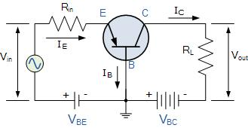

This type of amplifier configuration is a non-inverting voltage amplifier circuit, in that the signal voltages Vin and Vout are “in-phase”. This type of transistor arrangement is not very common due to its unusually high voltage gain characteristics. Its input characteristics represent that of a forward biased diode while the output characteristics represent that of an illuminated photo-diode.

Also this type of bipolar transistor configuration has a high ratio of output to input resistance or more importantly “load” resistance ( RL ) to “input” resistance ( Rin ) giving it a value of “Resistance Gain”. Then the voltage gain ( Av ) for a common base configuration is therefore given as:

Common Base Voltage Gain
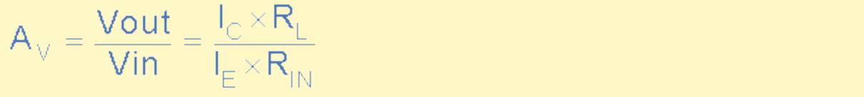

Where: Ic/Ie is the current gain, alpha ( α ) and RL/Rin is the resistance gain.

The common base circuit is generally only used in single stage amplifier circuits such as microphone pre-amplifier or radio frequency ( Rƒ ) amplifiers due to its very good high frequency response.

The Common Emitter (CE) Configuration

In the Common Emitter or grounded emitter configuration, the input signal is applied between the base and the emitter, while the output is taken from between the collector and the emitter as shown. This type of configuration is the most commonly used circuit for transistor based amplifiers and which represents the “normal” method of bipolar transistor connection.

The common emitter amplifier configuration produces the highest current and power gain of all the three bipolar transistor configurations. This is mainly because the input impedance is LOW as it is connected to a forward biased PN-junction, while the output impedance is HIGH as it is taken from a reverse biased PN-junction.
The Common Emitter Amplifier Circuit
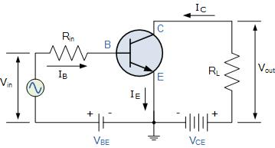

In this type of configuration, the current flowing out of the transistor must be equal to the currents flowing into the transistor as the emitter current is given as Ie = Ic + Ib.

As the load resistance ( R_{L} ) is connected in series with the collector, the current gain of the common emitter transistor configuration is quite large as it is the ratio of Ic/Ib. A transistors current gain is given the Greek symbol of Beta, ( β ).

As the emitter current for a common emitter configuration is defined as Ie = Ic + Ib, the ratio of Ic/Ie is called Alpha, given the Greek symbol of α. Note: that the value of Alpha will always be less than unity.

Since the electrical relationship between these three currents, Ib, Ic and Ie is determined by the physical construction of the transistor itself, any small change in the base current ( Ib ), will result in a much larger change in the collector current ( Ic ).

Then, small changes in current flowing in the base will thus control the current in the emitter-collector circuit. Typically, Beta has a value between 20 and 200 for most general purpose transistors. So if a transistor has a Beta value of say 100, then one electron will flow from the base terminal for every 100 electrons flowing between the emitter-collector terminal.

By combining the expressions for both Alpha, α and Beta, β the mathematical relationship between these parameters and therefore the current gain of the transistor can be given as:
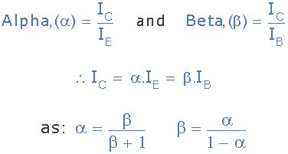
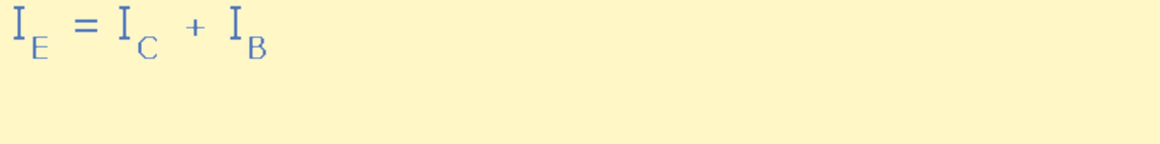

Where: “Ic” is the current flowing into the collector terminal, “Ib” is the current flowing into the base terminal and “Ie” is the current flowing out of the emitter terminal.

Then to summarise a little. This type of bipolar transistor configuration has a greater input impedance, current and power gain than that of the common base configuration but its voltage gain is much lower. The common emitter configuration is an inverting amplifier circuit. This means that the resulting output signal has a 180º phase-shift with regards to the input voltage signal.

The Common Collector (CC) Configuration

In the Common Collector or grounded collector configuration, the collector is connected to ground through the supply, thus the collector terminal is common to both the input and the output. The input signal is connected directly to the base terminal, while the output signal is taken from across the emitter load resistor as shown. This type of configuration is commonly known as a Voltage Follower or Emitter Follower circuit.

The common collector, or emitter follower configuration is very useful for impedance matching applications because of its very high input impedance, in the region of hundreds of thousands of Ohms while having a relatively low output impedance.

The Common Collector Transistor Circuit
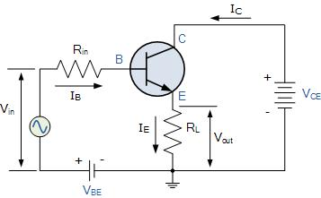

The common emitter configuration has a current gain approximately equal to the β value of the transistor itself. However in the common collector configuration, the load resistance is connected in series with the emitter terminal so its current is equal to that of the emitter current.

As the emitter current is the combination of the collector AND the base current combined, the load resistance in this type of transistor configuration also has both the collector current and the input current of the base flowing through it. Then the current gain of the circuit is given as:

The Common Collector Current Gain
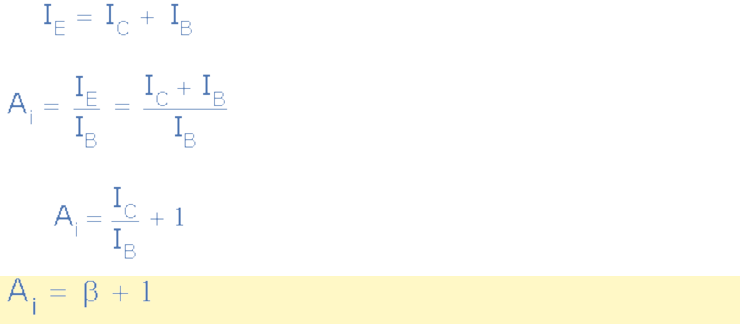

This type of bipolar transistor configuration is a non-inverting circuit in that the signal voltages of Vin and Vout are “in-phase”. The common collector configuration has a voltage gain of about “1” (unity gain). Thus it can considered as a voltage-buffer since the voltage gain is unity.

The load resistance of the common collector transistor receives both the base and collector currents giving a large current gain (as with the common emitter configuration) therefore, providing good current amplification with very little voltage gain.

Having looked at the three different types of bipolar transistor configurations, we can now summarise the various relationships between the transistors individual DC currents flowing through each leg and its DC current gains given above in the following table.

Relationship between DC Currents and Gains
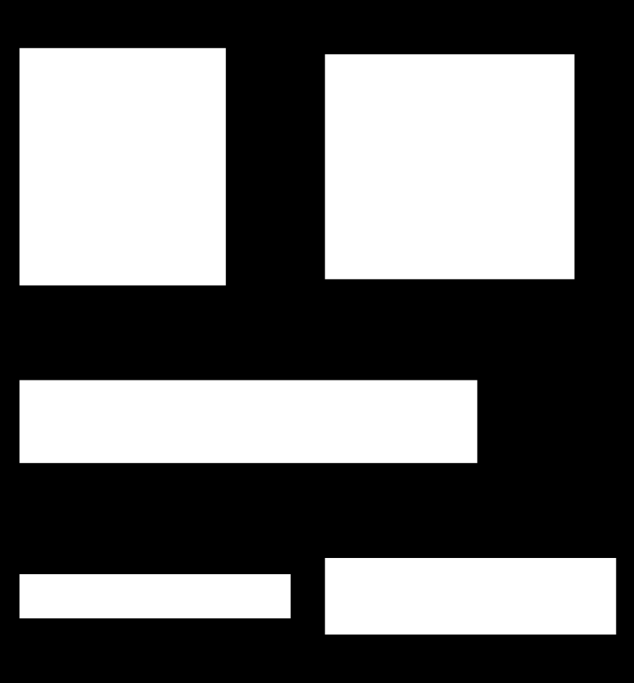
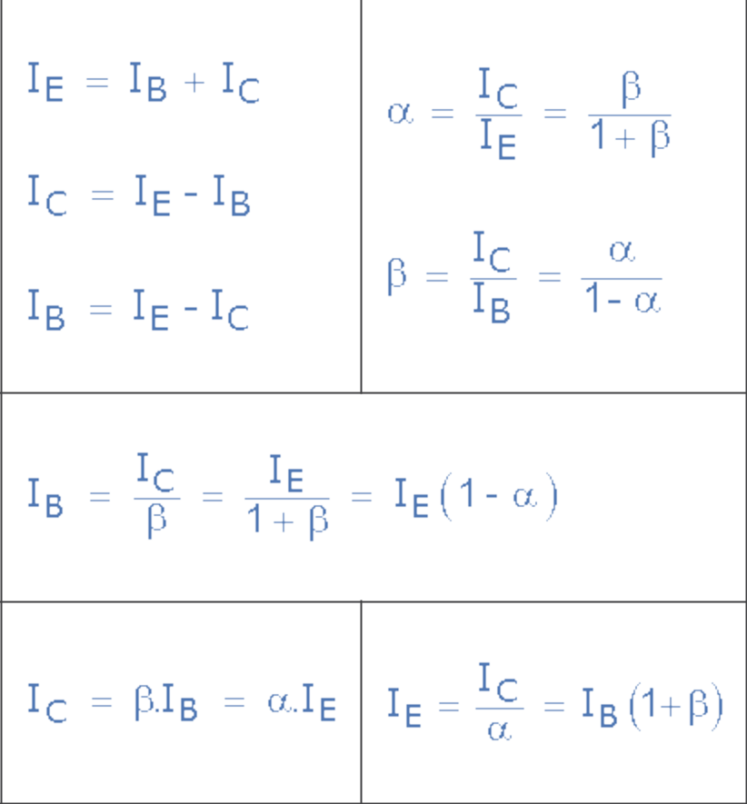
Light Emitting Diode (LED)

It is most widely used semiconductor which emit either visible light or invisible infrared light when forward biased. Remote controls generate invisible light. A Light emitting diodes (LED) is an optical electrical energy into light energy when voltage is applied.
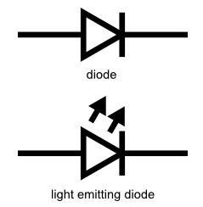

In forward biased, energy is released in the form of light when free electrons in conduction band recombines with holes in the valence band. This process is called electroluminescence. Like a normal p-n junction diode allows electric current only in direction, LEDs also operates only in forward bias condition. The n-type material should be negatively charged and p-type material should be positively charged to create an LED.

Working of LED

Light Emitting Diode (LED) works only in forward biased condition where free electrons are from n-side and the holes from p-side are pushed towards the junction. The recombination of free electrons and holes takes place in depletion region as well as in p-type and n-type semiconductor. The free electrons in conduction band releases energy in the form of light before they recomine with holes in the valence band.

When external voltage is applied to valence electrons, the valence electrons which breaks bonding with parent atom are called free electrons and that empty space is called a hole. The grouping the range of energy levels of all the valence is called valence band.

Since energy of free electrons is always more than the energy of valence electrons or holes, so it need to lose energy in order to recombine with holes. Hence each recombination of charge emits energy in the form of light. The brightness of the emitted light is depends on the materials used for conducting LED and forward current flow through the LED.
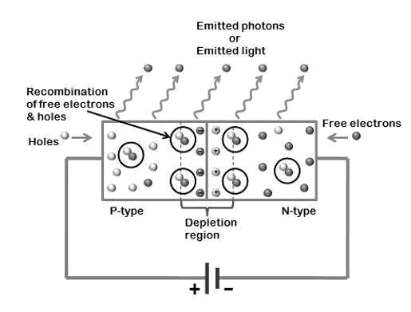

In normal silicon diodes, energy gap between conduction and valence band is less, so low energy photons are released which low frequency and invisible to human eye. Whereas, in LED, energy gap between conduction and valence band is very large so high energy photons released and visible to human eye.

Since LEDs are operate only forward bias condition, so if reverse bias voltage is applied to LED, it may be damaged. LEDs can switched ON and OFF at a very fast speed of 1 ns. The most common colors of LEDs are green, red, orange, and yellow but schematic symbol is same.

Types of LED

There are two classes of light emitting diodes, these are visible LEDs and invisible LEDs. Also, the wavelength or color of emitting light depends on the forbidden gap or energy gap of the materials. These are various types of light emitting diodes:

- Gallium Arsenide (GaAs) – infrared

- Gallium Arsenide Phosphide (GaAsP) – red to infrared, orange

- Aluminium Gallium Arsenide Phosphide (AlGaAsP) – high-brightness red, orange-red, orange, and yellow
- Gallium Phosphide (GaP) – red, yellow and green

- Aluminium Gallium Phosphide (AlGaP) – green

- Gallium Nitride (GaN) – green, emerald green

- Gallium Indium Nitride (GaInN) – near ultraviolet, bluish-green and blue

- Silicon Carbide (SiC) – blue as a substrate

- Zinc Selenide (ZnSe) – blue

Applications of LED:

These are various applications of LEDs:

- Digital computers and calculators

- Traffic signals and Burglar alarms systems

- Microprocessors and multiplexers

- Picture phones and digital watches

- Camera flashes and automotive heat lamps

- Aviation lighting
Photodiode

It is a form of light-weight sensor that converts light energy into electrical voltage or current. Photodiode is a type of semi conducting device with PN junction. Between the p (positive) and n (negative) layers, an intrinsic layer is present. The photo diode accepts light energy as input to generate electric current.

It is also called as Photodetector, photo sensor or light detector. Photo diode operates in reverse bias condition i.e. the p – side of the photodiode is connected with negative terminal of battery (or the power supply) and n – side to the positive terminal of battery.

Typical photodiode materials are Silicon, Germanium, Indium Gallium Arsenide Phosphide and Indium gallium arsenide.

The symbol of the photodiode is similar to that of an LED but the arrows point inwards as opposed to outwards in the LED. The following image shows the symbol of a photodiode.
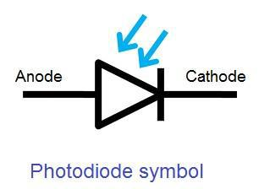

Working of a Photodiode

Generally, when a light is made to illuminate the PN junction, covalent bonds are ionized. This generates hole and electron pairs. Photocurrents are produced due to generation of electron-hole pairs. Electron hole pairs are formed when photons of energy more than 1.1eV hits the diode. When the photon enters the depletion region of diode, it hits the atom with high energy. This results in release of electron from atom structure. After the electron release, free electrons and hole are produced.
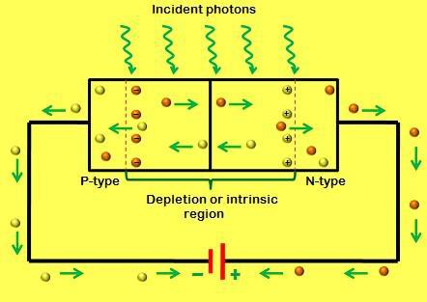

In general, an electron will have negative charge and holes will have a positive charge. The depletion energy will have built in electric filed. Due to that electric filed, electron hole pairs moves away from the junction. Hence, holes move to anode and electrons move to cathode to produce photo current. The photon absorption intensity and photon energy are directly proportional to each other. When energy of photos is less, the absorption will be more. This entire process is known as Inner Photoelectric Effect.

Intrinsic Excitations and Extrinsic Excitations are the two methods via which the photon excitation happens. The process of intrinsic excitation happens, when an electron in the valence band is excited by photon to conduction band.
Laser

“Laser” is an acronym for Light Amplification by Stimulated Emission of Radiation. A laser is created when the electrons in atoms in special glasses, crystals, or gases absorb energy from an electrical current or another laser and become “excited.” The excited electrons move from a lower-energy orbit to a higher-energy orbit around the atom’s nucleus. When they return to their normal or “ground” state, the electrons emit photons (particles of light).

Principles of working of a laser

In lasers, photons are interacted in three ways with the atoms:

- Absorption of radiation

- Spontaneous emission

- Stimulated emission

Absorption of radiation:-

Absorption of radiation is the process by which electrons in the ground state absorbs energy from photons to jump into the higher energy level.

The electrons orbiting very close to the nucleus are at the lower energy level or lower energy state whereas the electrons orbiting farther away from the nucleus are at the higher energy level. The electrons in the lower energy level need some extra energy to jump into the higher energy level. This extra energy is provided from various energy sources such as heat, electric field, or light.

Let us consider two energy levels (E₁ and E₂) of electrons. E₁ is the ground state or lower energy state of electrons and E₂ is the excited state or higher energy state of electrons. The electrons in the ground state are called lower energy electrons or ground state electrons whereas the electrons in the excited state are called higher energy electrons or excited electrons.
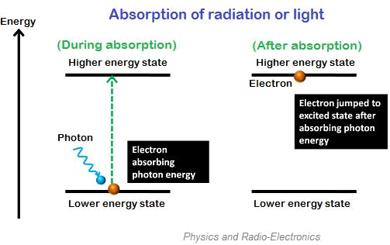

In general, the electrons in the lower energy state can’t jump into the higher energy state. They need sufficient energy in order jump into the higher energy state.

When photons or light energy equal to the energy difference of the two energy levels (E₂ – E₁) is incident on the atom, the ground state electrons gains sufficient energy and jumps from ground state (E₁) to the excited state (E₂).

The absorption of radiation or light occurs only if the energy of incident photon exactly matches the energy difference of the two energy levels (E₂ – E₁).

Spontaneous emission:-

Spontaneous emission is the process by which electrons in the excited state return to the ground state by emitting photons. The electrons in the excited state can stay only for a short period. The time up to which an excited electron can stay at higher energy state (E₂) is known as the lifetime of excited electrons. The lifetime of electrons in excited state is 10⁻⁸ second.
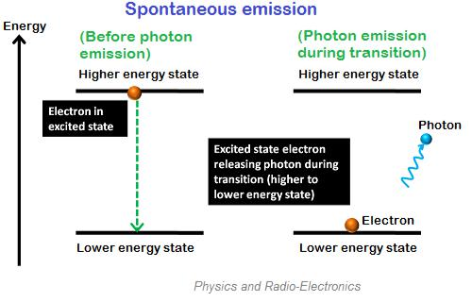

Thus, after the short lifetime of the excited electrons, they return to the lower energy state or ground state by releasing energy in the form of photons.

In spontaneous emission, the electrons move naturally or spontaneously from one state (higher energy state) to another state (lower energy state) so the emission of photons also occurs naturally. Therefore, we have no control over when an excited electron is going to lose energy in the form of light.

The photons emitted in spontaneous emission process constitute ordinary incoherent light. Incoherent light is a beam of photons with frequent and random changes of phase between them. In other words, the photons emitted in the spontaneous emission process do not flow exactly in the same direction of incident photons.

Stimulated emission:-

Stimulated emission is the process by which incident photon interacts with the excited electron and forces it to return to the ground state.

In stimulated emission, the light energy is supplied directly to the excited electron instead of supplying light energy to the ground state electrons.

Unlike the spontaneous emission, the stimulated emission is not a natural process it is an artificial process.

In spontaneous emission, the electrons in the excited state will remain there until its lifetime is over. After completing their lifetime, they return to the ground state by releasing energy in the form of light.

However, in stimulated emission, the electrons in the excited state need not wait for completion of their lifetime. An alternative technique is used to forcefully return the excited electron to ground state before completion of their lifetime. This technique is known as the stimulated emission.

When incident photon interacts with the excited electron, it forces the excited electron to return to the ground state. This excited electron release energy in the form of light while falling to the ground state.
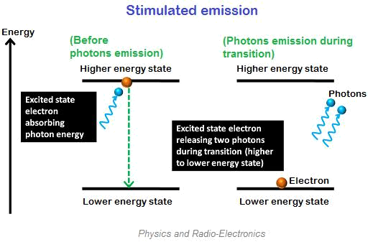

In stimulated emission, two photons are emitted (one additional photon is emitted), one is due to the incident photon and another one is due to the energy release of excited electron. Thus, two photons are emitted.The stimulated emission process is very fast compared to the spontaneous emission process.

All the emitted photons in stimulated emission have the same energy, same frequency and are in phase. Therefore, all photons in the stimulated emission travel in the same direction. The number of photons emitted in the stimulated emission depends on the number of electrons in the higher energy level or excited state and the incident light intensity.

Boolean Algebra

As well as the logic symbols “0” and “1” being used to represent a digital input or output, we can also use them as constants for a permanently “Open” or “Closed” circuit or contact respectively.

A set of rules or Laws of Boolean Algebra expressions have been invented to help reduce the number of logic gates needed to perform a particular logic operation resulting in a list of functions or theorems known commonly as the Laws of Boolean Algebra.

Boolean Algebra is the mathematics we use to analyse digital gates and circuits. We can use these “Laws of Boolean” to both reduce and simplify a complex Boolean expression in an attempt to reduce the number of logic gates required. Boolean Algebra is therefore a system of mathematics based on logic that has its own set of rules or laws which are used to define and reduce Boolean expressions.

The variables used in Boolean Algebra only have one of two possible values, a logic “0” and a logic “1” but an expression can have an infinite number of variables all labelled individually to represent inputs to the expression, For example, variables A, B, C etc, giving us a logical expression of A + B = C, but each variable can ONLY be a 0 or a 1.

Examples of these individual laws of Boolean, rules and theorems for Boolean Algebra are given in the following table.

Truth Tables for the Laws of Boolean
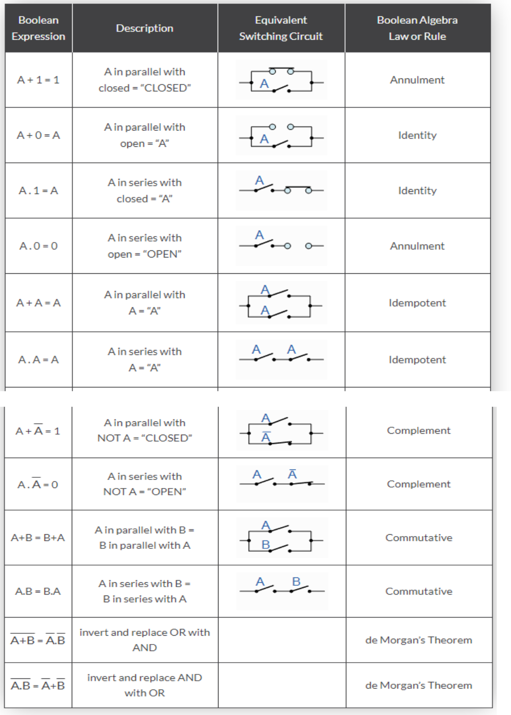
The basic Laws |  | of Boolean |  | Algebra that |  | relate | to | the Commutative
Law allowing | a | change in | position for |  | addition |  | and |  | multiplication,
the Associative | Law allowing |  | the | removal | of | brackets |  | for | addition and

multiplication, as well as the Distributive Law allowing the factoring of an expression, are the same as in ordinary algebra.

Each of the Boolean Laws above are given with just a single or two variables, but the number of variables defined by a single law is not limited to this as there can be an infinite number of variables as inputs too the expression. These Boolean laws detailed above can be used to prove any given Boolean expression as well as for simplifying complicated digital circuits.

A brief description of the various Laws of Boolean are given below with A representing a variable input.

Description of the Laws of Boolean Algebra

- Annulment Law – A term AND´ed with a “0” equals 0 or OR´ed with a “1” will equal 1

- Identity Law – A term OR´ed with a “0” or AND´ed with a “1” will always equal that term

- Idempotent Law – An input that is AND´ed or OR´ed with itself is equal to that input
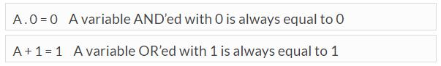
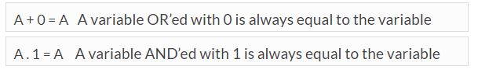
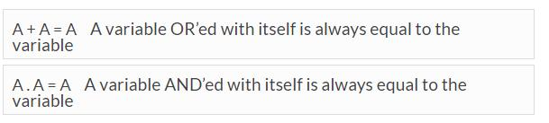

- Complement Law – A term AND´ed with its complement equals “0” and a

term OR´ed with its complement equals “1”

•

o | A.A=0 | A variable AND’ed with its complement is always equal
 | to 0
o | A+A=1 | A variable OR’ed with its complement is always equal to
 | 1

•

- Commutative Law – The order of application of two separate terms is not important
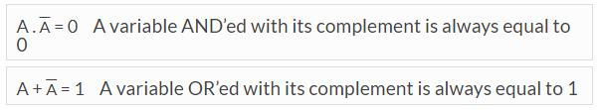

- Double Negation Law – A term that is inverted twice is equal to the original term
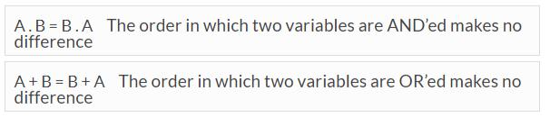

- de Morgan´s Theorem – There are two “de Morgan´s” rules or theorems,
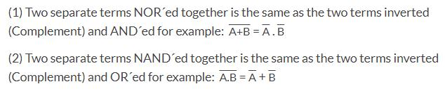
2-input AND Gate

For a 2-input AND gate, the output Q is true if BOTH input A “AND” input B are both true, giving the Boolean Expression of: ( Q = A and B ).
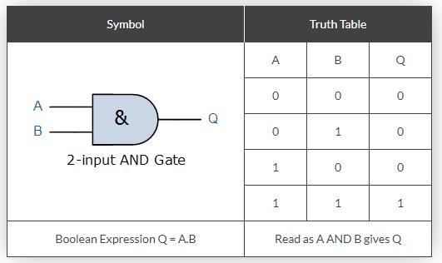

Note that the Boolean Expression for a two input AND gate can be written as: A.B or just simply AB without the decimal point.

2-input OR Gate

For a 2-input OR gate, the output Q is true if EITHER input A “OR” input B is true, giving the Boolean Expression of: ( Q = A or B ).
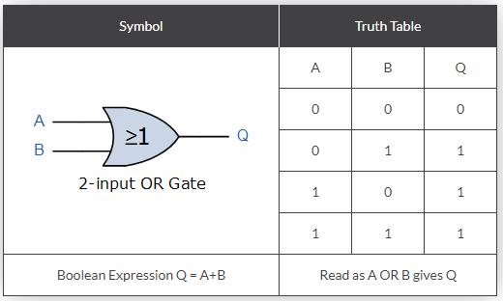
NOT Gate (Inverter)

For a single input NOT gate, the output Q is ONLY true when the input is “NOT” true, the output is the inverse or complement of the input giving the Boolean Expression of: ( Q = NOT A ).
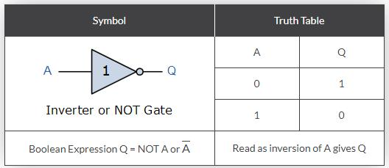

The NAND and the NOR Gates are a combination of the AND and OR Gates respectively with that of a NOT Gate (inverter).

2-input NAND (Not AND) Gate

For a 2-input NAND gate, the output Q is true if BOTH input A and input B are NOT true, giving the Boolean Expression of: ( Q = not(A AND B) ).
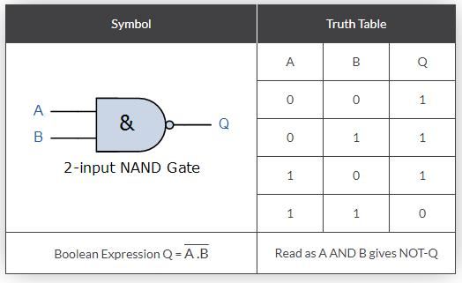
2-input NOR (Not OR) Gate

For a 2-input NOR gate, the output Q is true if BOTH input A and input B are NOT true, giving the Boolean Expression of: ( Q = not(A OR B) ).
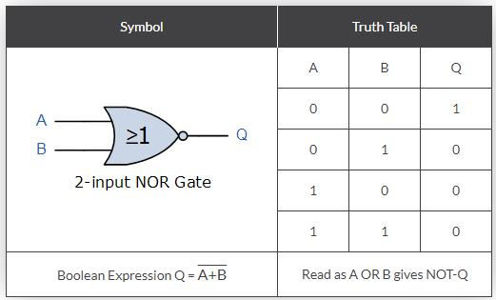

As well as the standard logic gates there are also two special types of logic gate function called an Exclusive-OR Gate and an Exclusive-NOR Gate. The Boolean expression to indicate an Exclusive-OR or Exclusive-NOR function is to a symbol with a plus sign inside a circle, ( ⊕ ).

2-input EX-OR (Exclusive OR) Gate

For a 2-input Ex-OR gate, the output Q is true if EITHER input A or if input B is true, but NOT both giving the Boolean Expression of: ( Q = (A and NOT B) or (NOT A and B) ).
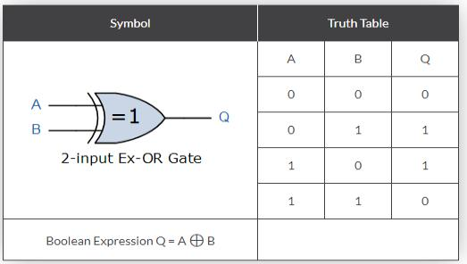

2-input EX-NOR (Exclusive NOR) Gate

For a 2-input Ex-NOR gate, the output Q is true if BOTH input A and input B are the same, either true or false, giving the Boolean Expression of: ( Q = (A and B) or (NOT A and NOT B) ).
